

Capstone Project Phase A

**24-1-D-9**

**Earth Keepers**

**https://github.com/raeedAtaria1/finalProject**

**Supervisor: Dr. Reuven Cohen**

**Students:**

**Suhel Khoury**

**&**

**Raeed Ataria**

Contents

Abstract 3

1. Introduction 4

2. Literature Survey 5

2.1 Similar friendly and gaming apps 5

2.2 Possible approaches and tools for detecting objects in images. 6

2.3 Robots with similar goals for collecting objects 10

3. Expected Achievements 11

3.1 User-Friendly Interface 12

3.2 Capturing and analyzing a real-time video using Mobile Camera 12

3.3 Success criteria of the project: 12

4. Engineering Process 13

4.1 The process of crafting software and conducting research 13

**4.1.1 Requirements** 14

**4.1.2 Deciding which technologies we will use** 15

**4.1.3 Environments** 16

**4.1.4 Datasets** 17

**4.1.5 Development method** 19

**4.1.6 Challenges** 19

4.2 product 20

**4.2.1 Software Architecture Diagram** 20

**4.2.2 UseCase Diagram** 22

**4.2.3 Activity Diagram** 23

**4.2.4 User-Friendly Interface** 24

5. Verification Plan: 28

5.1 Tests 28

5.2 Constraints 32

5.3 Assumptions 32

5.4 Other important considerations: user’s evaluation, and feedback 33

**5.4.1 User Interface Evaluation** 33

**5.4.2 Asking for General Feedback** 33

6. References 33

# **Abstract**

The increasing prevalence of uncollected trash in public spaces poses a severe environmental threat that demands immediate attention and action. To address this issue, this project proposes an innovative solution that redefines the process of waste collection by introducing an engaging and gamified approach. The proposed solution is a machine learning-powered mobile application that employs a body camera to seamlessly detect and categorize trash in real-time, rewarding participants with points for each successfully collected item.

The app leverages computer vision techniques, such as Convolutional Neural Networks (CNNs) and the YOLOv9 object detection algorithm, to achieve accurate and efficient trash recognition. Additionally, the project incorporates MediaPipe's hand tracking capabilities to recognize the gesture of grabbing trash items, further enhancing the interactivity and user experience.

The target audience for this solution comprises individuals who are devoted to enhancing the environment. By offering a gamified approach, the project aims to encourage these individuals to actively participate in trash collection efforts, making the process both enjoyable and rewarding. The verification plan includes a comprehensive set of tests to assess the accuracy of hand detection, trash item recognition, counting mechanisms, and overall system performance, as well as gathering feedback from users to evaluate the efficiency and user-friendliness of the application.

The successful implementation of this project has the potential to significantly contribute to the reduction of uncollected trash in public spaces, fostering environmental awareness and encouraging community-driven initiatives for a cleaner and more sustainable future.

# **1. Introduction**

The increasing prevalence of uncollected trash in beaches and public places poses a severe environmental threat that demands immediate attention and action. This concerning issue stems from a combination of factors, including human negligence and a lack of interest in actively participating in trash collection efforts. While some communities organize regular clean-up events and volunteer initiatives, others struggle to mobilize residents to take meaningful action. So, the real problem is how to encourage the residents themselves to take a part in collecting the trash and save our planet.

To solve this problem, various approaches have been suggested. Some propose providing educational and environmental awareness through campaigns, while others advocate for incentivizing people with financial rewards. Technological solutions such as mobile apps and social media platforms have also been explored to facilitate community organizing and communication for clean-up efforts. An existing mobile app called CleanCoin exemplifies this by rewarding users with coupons for taking images while they are participating in trash collection activities.

Building upon these ideas, our innovative solution redefines the process of waste collection by introducing an engaging element. Our app is a machine learning-powered app that employs a body camera to seamlessly detect and categorize trash in real-time using advanced algorithms, rewarding participants with points for each successfully collected item. Users will hear a beep sound when they pick up an item, enhancing the interactive experience. Furthermore, the solution incorporates a gamified aspect, fostering healthy competition among users and offering them the opportunity to compete with others.

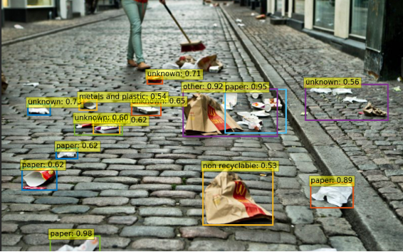

Figure 1: YOLO-identified image featuring various trash items.

The project is specifically tailored for targeted individuals who are devoted to enhancing the environment. Through the gamified approach, we aim to encourage these individuals to actively participate in trash collection efforts, making the process both enjoyable and rewarding.

# **2. Literature Survey**

There are already several approaches and attempts to encourage the residents themselves to take a part in collecting the trash and save our planet, some of them use Machine-Learning. For achieving more reliable and accurate results we are going to use Machine learning in our project. Within this expansive realm, a multitude of methods exist for classifying and detecting objects, especially in cluttered environments. Let's dive into some of the approaches within this domain.

## **2.1 Similar friendly and gaming apps**

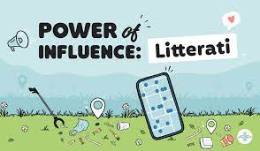

Figure 2: Letterati app

**Litterati** is an app that facilitates user engagement in litter management through taking pictures, tagging, and geolocation of collected litter [7].

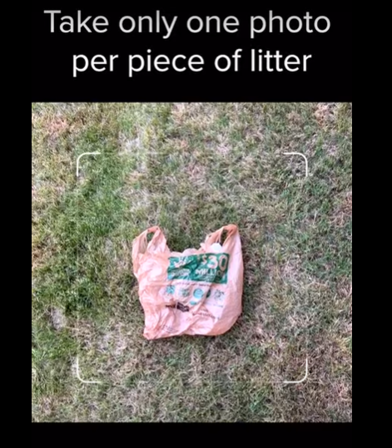

Figure 3: Example image demonstrating proper picture-taking guidelines within the app.

The process of uploading the pictures in Litterati has its limitations. First, to ensure capturing an image with the minimal required quality to detect and classify the litter, it is necessary to stay steady while taking a picture of it and keeping the litter fully visible. Second, the user must take one photo per litter. In other words, he cannot detect multiple litters per one photo. Finally, he must make sure that there is sufficient light.



Figure 4: clean coin logo

**Clean coin**

The app turns cleaning into a game, uniting users to clean up trash. The app have tasks including mapping trash or collecting it. After finishing the cleaning task, the users put the trash at one of the designated drop-off points, and take a selfie for confirmation. After the app validates the selfie, and the drop-off point, the user finally can choose rewards like cash, discounts, or charity donations as a reward [1].

## **2.2 Possible approaches and tools for detecting objects in images.**

**CNN**

Convolutional neural network (CNNs) is an important technic for sophisticated computer vision analysis. Its architecture structure contains:

1. An input layer that receives the raw image data.   
2. Convolutional layers to perform convolutions over the input using filters, activating on detected features.

3. Pooling layers for reducing the dimensions of the input.

4. Fully connected layers for classifying the extracted features by connecting all neurons between two adjacent layers.

5. Output layer that produces the final class score [9].

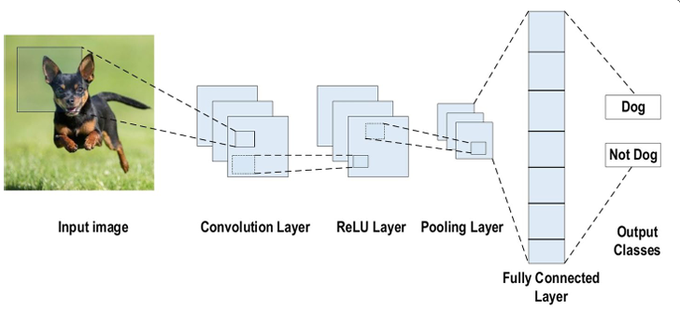

Figure 5: CNN network

**Mask R-CNN & Mask Scoring R-CNN**

Mask Scoring R-CNN is a model for instance segmentation, which aims to detect and outline individual objects within an image.

. Mask quality relies on the classification confidence score as an indicator, which isn't always accurate.

it Inherits everything from Mask R-CNN (Detects objects, classifies them, and predicts a binary mask for each instance), plus predicts the Intersection over Union (IoU) between the predicted mask and the ground truth mask. This way enables to estimate the quality of the predicted mask, leading to better confidence scores. It can be used for real-time object detection [6] [10].

**Grid-based detection**

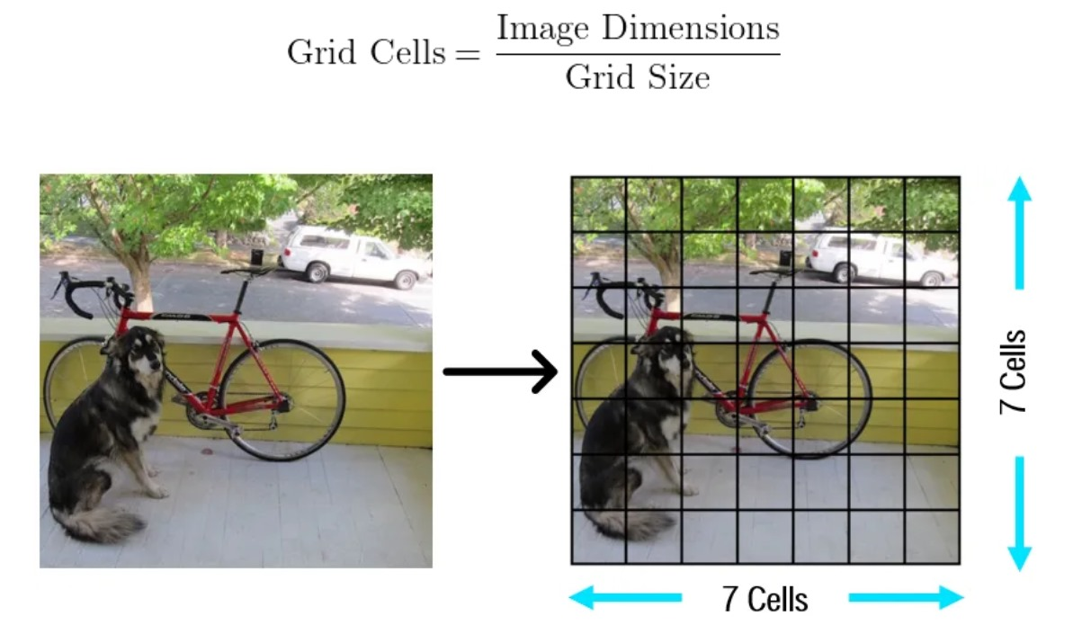

Figure 6: Grid-based detection

Grid-based detection involves the partitioning of the image into a grid of cells, updating the occupancy status of the grid cells, and detecting moving objects based on deviations from the expected occupancy. This approach enables simultaneous localization, mapping, and detection of moving objects in dynamic outdoor environments.

**YOLOv9 (You Only Look Once)**

YOLO (You Only Look Once) is a popular object detection algorithm due to its efficiency and effectiveness. Predicting bounding boxes and class probabilities directly from the full image in one evaluation.

The key idea behind YOLO is the partition of the input image into grid cell that are processed by a series of CNN convolution and pooling layers with output of a very small matrix. Lastly, the output matrix is processed by a fully connected layer that predicts the bounding boxes and provides the class probabilities for the objects located within each grid cell.

This approach enables YOLO to achieve a real-time performance, as it only requires a single pass through the neural network to make predictions for the entire image [4].

YOLO has undergone several versions, where each version introduces improvements in accuracy, speed, and robustness. The YOLOv9 algorithm, introduced in 2024, has achieved exceptional accuracy, surpassing previous versions [see figure 7]. For example, version 9 has 49% fewer parameters compared to YOLOv8 and a 43% reduction in computations, and a 0.6% increase in AP (Average Precision).

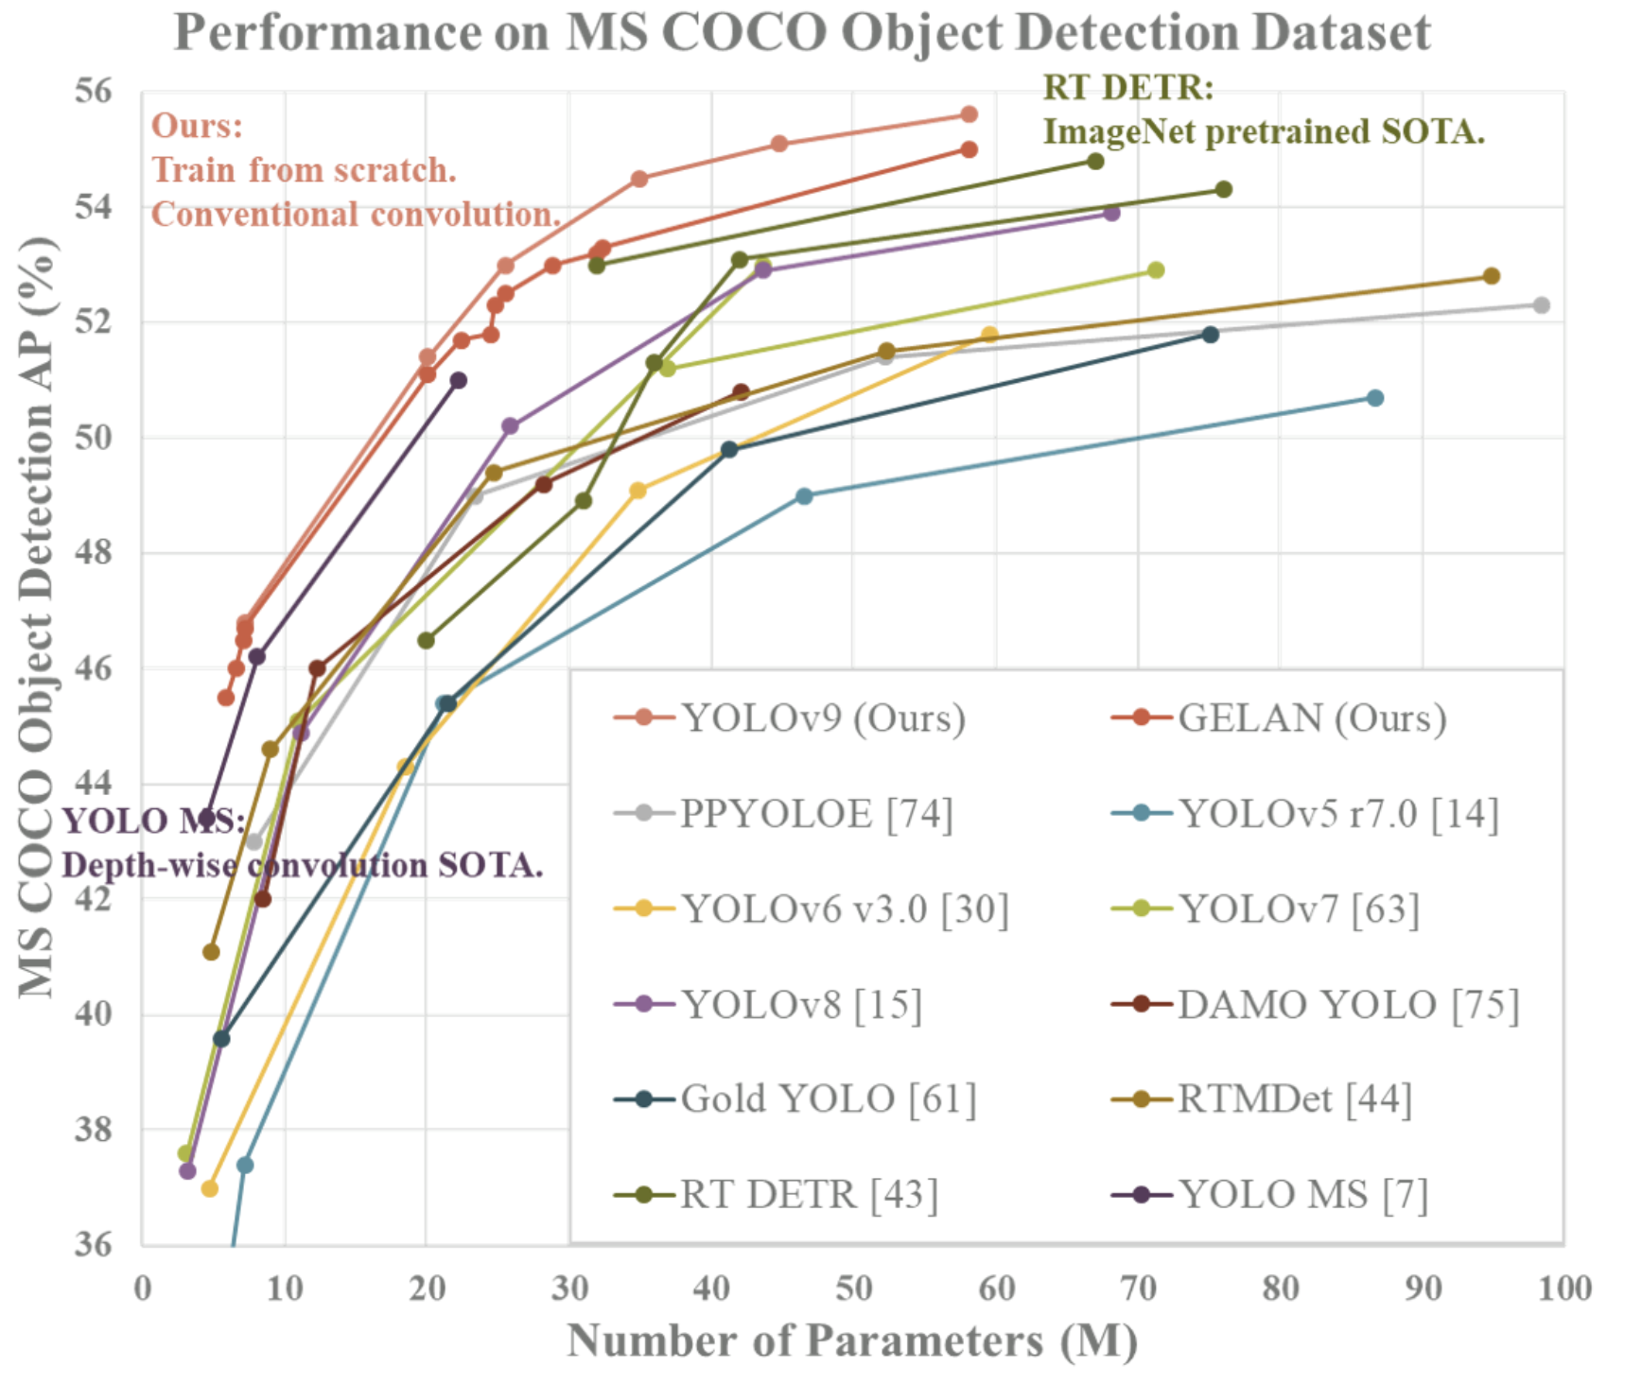

Figure 7: YOLOv9 performance in comparison with the previous versions

To achieve that, YOLOv9 adopts the improved Darknet-53 backbone network, making it significantly faster and more accurate than the predecessors. Furthermore, YOLOv9 uses a larger feature map and a more efficient convolutional network making it more efficient and accurate in capturing the complex relationships between the features [4].

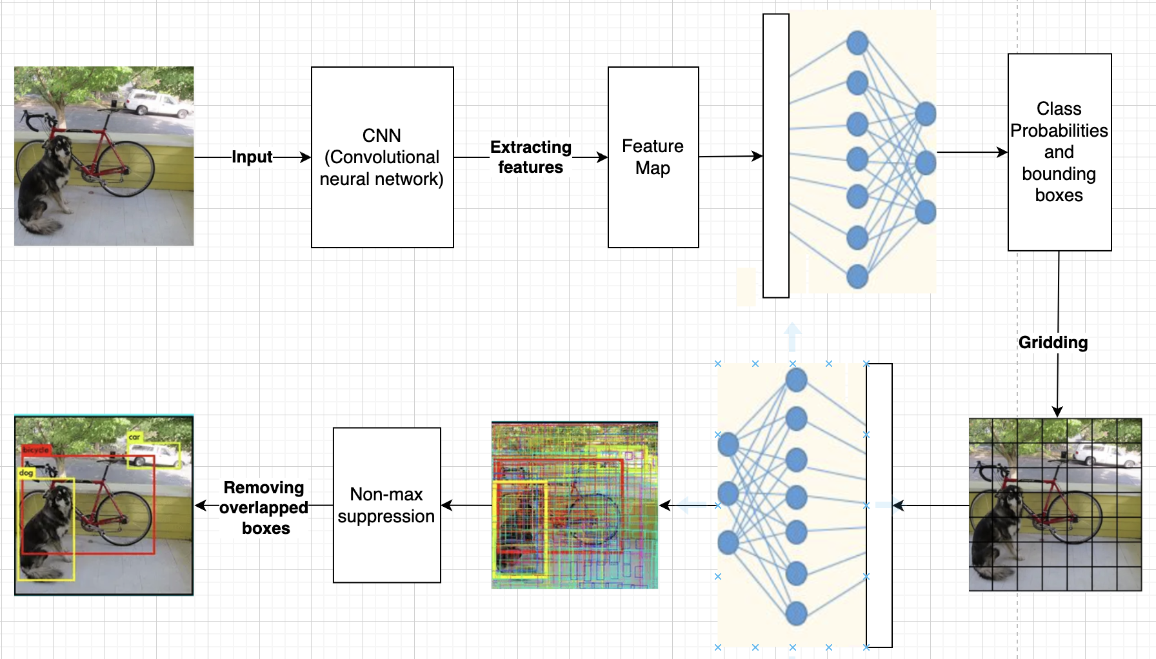

Figure 8: YOLO structure

**MediaPipe**

MediaPipe is an efficient and usable framework designed for constructing machine learning pipelines tailored for processing time-series data such as video and audio. It relies on OpenCV for video processing and FFMPEG for audio handling, and more other tools like OpenGL Tensorflow libraries. It is compatible with various platforms including Desktop, Android, and iOS. In fact, Nowadays, it has been utilized by Google, like Google Lens, Google Photos, and Gmail, and many other projects [5] [](#num5)[3].

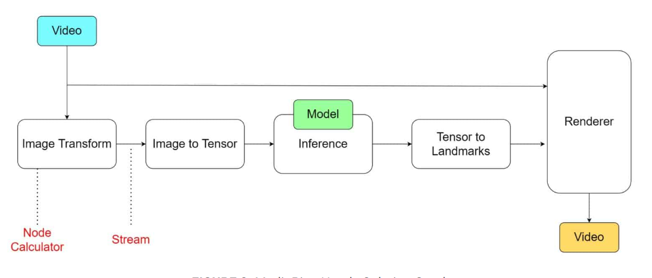

Figure 9: Visual demonstration of MediaPipe's functionality and operation

One of the key benefits of using MediaPipe, is that it can detect key points on the body such as face, hands, legs, and fingers, and track their positions, making it feasible to grasp the motion and the movement of the body.

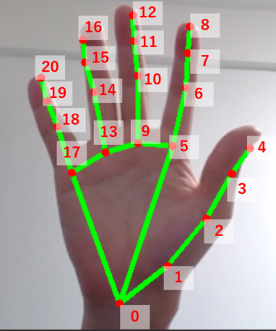

Figure 10: 21 hand landmarks used in MediaPipe

## **2.3 Robots with similar goals for collecting objects**

**BAXTER Robot**

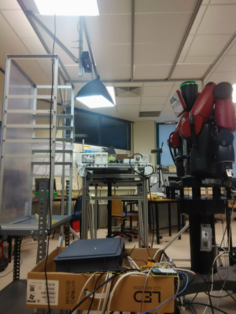

Figure 11: BAXTER Robot

The BAXTER robot by AMAZON Robotics is designed to identify specific items amidst a vast array of objects and return them to a mobile shelf. This process involves utilizing OpenCV and Python Image Libraries for image processing tasks. Tensorflow is predominantly used to integrate YOLO and RESNET neural network model, for the object recognition [2].

ِ

**Automatic robot for picking up garbage**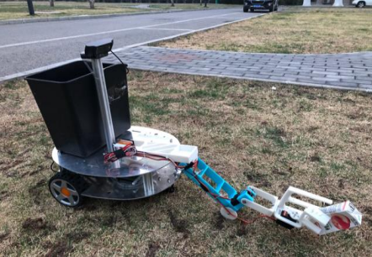

Figure 12: Automatic robot for picking up garbage

This robot is designed for detecting the garbage and collecting it into the trash.  
Besides the localization and the navigation modules of the robot, it has a perception module. The robot has an object tracker and detector that can determine whether the object is a trash. The module includes garbage recognition and localization for picking up the garbage[8].

# **3. Expected Achievements**

Our project is a user-friendly mobile app that encourages people to collect trash through gamification and social engagement. The users get points when they collect trash, fostering friendly competition among friends and to motivate participation. The app makes a beep sound when an item is collected allowing users to receive real-time feedback.

1. Creating a User-Friendly Interface for our project
2. Capturing real-time video footage using Mobile Camera
3. Accurate Real-Time Trash Detection and Classifying
4. Accurate Real-Time Recognition of Grabbing the Trash by Hand

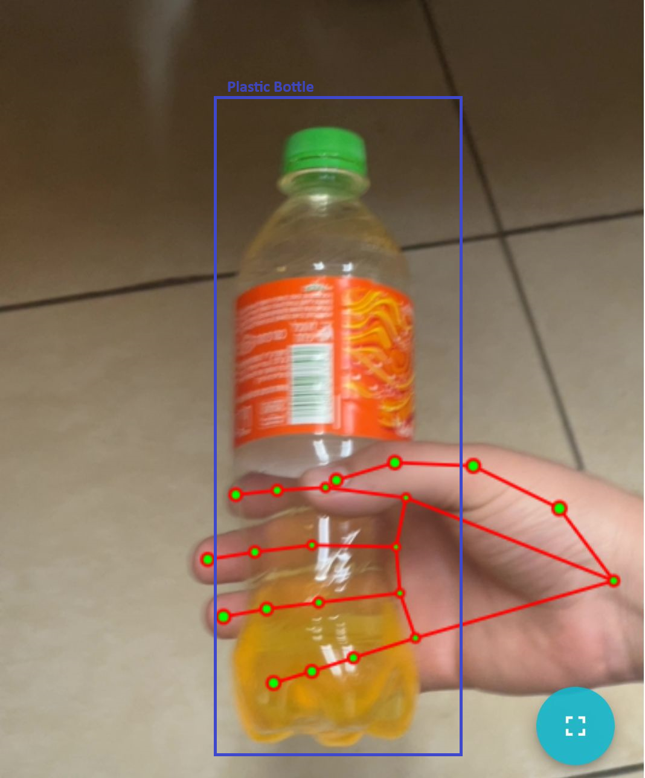

Figure 13: Visual representation showcasing the anticipated appearance and functionality of our app

## **3.1 User-Friendly Interface**

We plan to build a convenient interface that capture a real-time video, displays the type of the trash item that he is grabbed and makes a beep sound when the user grabs the item. In addition, it is important to display to the user how many points he earned in the current session and inform him of his progress.

## **3.2 Capturing and analyzing a real-time video using Mobile Camera**

Capturing the movement of the hand while grabbing the trash object in real-time. We will use the Mobile phone Camera, to take an online video, and analyze it online using the YOLO and MediaPipe image analysis tools.

## **3.3 Success criteria of the project:**

1. Accuracy of Object Detection: Achieves a minimum of 90% precision in recognizing various sorts of trash items.

2. Accuracy of hand grabbing Detection.

3. Efficiency of Processing: Ensure that trash items identification and category take no more than 1 second per item in real-time.

4. Have a user-friendly interface for easy navigation and interaction.

5. Receiving good feedback from multiple users about the app.

# **4. Engineering Process**

## **4.1 The process of crafting software and conducting research**

This process consists of two stages:

**Stage A – The design:**

1. **Researching human littering and its environmental effects:** This step involves the study of existing researches and reading literature to understand the behavior of littering and its impact on the environment. We read many papers about the problem to help us determine what features our app should include.
2. **Searching for existing apps and software for trash collection:** This step entails the exploring of the landscape of available technology-driven solutions designed to encourage people to collect trash. We described some of them in the background chapter.
3. **Determining project requirements and features:** We investigated the specific needs and features that your project will entail, we checked what apps exist, and what they include.
4. **Determining which tools we want to use:** In this step, we will decide on the specific tools, technologies, and the frameworks we will utilize to develop our solution (We will address that later).
5. **Designing the architecture of the system:** This step includes the definition, the components, their interactions, the data flows, and the overall structure of the solution.
6. **Writing the activity and the use case diagrams:** we want to visually represent the flow of activities and the actions within the system.

The use cases describe interactions between users (actors) and the system to achieve specific goals.

**Stage B – The implementation:**

1. **Adjusting the code of MediaPipe and training the model on the dataset:** This step involves the modification of MediaPipe code to suit our project's needs and for training the model using the data from the given dataset.[See more about dataset]
2. **Adjusting the code of YOLO and training the model on the TACO and COCO datasets:** Similarly, we will customize the YOLO code to fit our requirements and train the model using the TACO (Trash Annotations in Context) and Microsoft COCO datasets. [See more about the datasets]
3. **Writing the backend code**, connecting the MediaPipe and YOLO code, and developing the entire backend.
4. **Writing the frontend code:** This step involves the development of the user interface and the client-side functionality of our application. We will create the front-end code using web technologies such as HTML, CSS, and JavaScript, ensuring a user-friendly experience for interacting with our system.
5. **Testing our code:** This step involves executing various tests to validate the functionality and performance of our code. We will conduct unit tests to verify individual components, integration tests to check interactions between modules, and system tests to evaluate the application as a whole.
6. **Managing the errors:** As we test your code, we will encounter errors and bugs, and we should solve them.
7. **Receiving feedback about the app from other people:** we will let people try the app and get their reactions, to make it more friendly, and make it more useful.

### **4.1.1 Requirements**

#### 4.1.1.1 Functional requirements:

1. The system allows the user to login into his account.
2. The system allows the user to sign up for a new account.
3. The system allows the user to start a session of collecting trash.
4. The system allows making a beeping sound.
5. The system allows counting the points of the picked up trash items.
6. The system allows the user to end the session.
7. The system allows presenting the total collected points to the user after the session.
8. The system allows the user to view his profile.
9. The system allows the user to view others' profiles.
10. The system allows the user to edit his profile.
11. The system allows the user to view score tables.

#### 4.1.1.2 Non-functional requirements:

1. The user can log in into his account using a username and password.
2. The user cannot login into his account if the accound wasn’t signed up first.
3. The user starts a session by clicking on the button “Start” on the home page.
4. The system makes a beep sound when the user picks a trash item.
5. Each item has different amount of points to earn, depending on its kind.
6. The user presses on the button “End session” to end the session
7. After clicking on “End session”, the user can see how many points he earned in that session.
8. The profile for each user includes: first and last names, location, total number of points, best score, and hand preference.
9. The user can change his prefered hand, whether it is left or right.
10. The user can change his first and last names.

### **4.1.2 Deciding which technologies we will use**

#### 4.1.2.1 Yolo:

YOLO: (You Only Look Once) object detection algorithm to recognize trash. YOLO divides the input image into a grid of cells, predicting bounding boxes and class probabilities for objects within each cell in a single pass through the neural network.

To achieve accurate predictions in trash detection, we are going to use YOLOv9, we will start by collecting images from Data sets (like TACO and COCO, and train YOLO, the training process involves iterating through the dataset, The model adjusts it`s parameters to minimize the predefined loss function, that will optimize its ability to detect and classify the objects.

After training the model with a dataset of various trash items and their labels, it should be capable of identifying different types of trash objects in images or video frames with high accuracy.

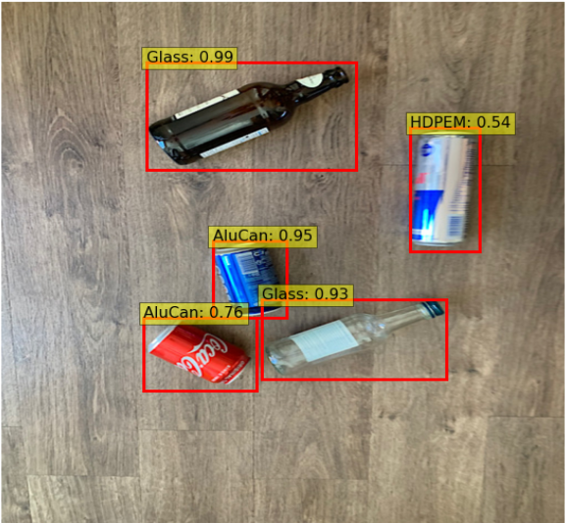

Figure 14: YOLO-identified image featuring various trash items.

#### 4.1.2.2 MediaPipe

We will use Mediapipe to help us to identify the pose of grabbing an object. In order to achieve that, we intend to train MediaPipe the hand movements related to holding items. We look to make it possible for MediaPipe to recognize and interpret gestures like closed fists or open palms, our program will count how many times the person grabbed an item, and check what the item is using YOLO.

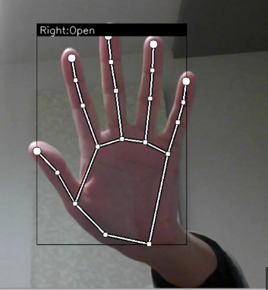

Figure 15: Detecting that the hand is open

### **4.1.3 Environments**

We will use a combination of Python for the Backend development and JavaScript, HTML, and CSS for the Frontend.

**Python** is a versatile and widely used programming language known for its simplicity and readability, making it an excellent choice for backend development. With Python, we can leverage powerful frameworks like Flask or Django to streamline the development process and handle tasks such as routing, database management, and authentication, and it is very good with deep learning, and most algorithms are implemented in it.

**JavaScript** is a fundamental programming language for web development, enabling dynamic and interactive user experiences. It runs directly in the browser, allowing us to create responsive and engaging web applications. With JavaScript, we can manipulate webpage elements, handle user input, and communicate with the server to fetch or send data asynchronously.

### **4.1.4 Datasets**

#### 4.1.4.1 Datasets for trash detection

**TACO**: we are going to use TACO dataset which is an open image dataset for litter and waste detection. The dataset contains 1500 different images with 4784 annotations. These annotations are labelled and classified into 60 categories which belong to 28 super or top categories. Below, the number of annotations is shown by both category and super category [10].

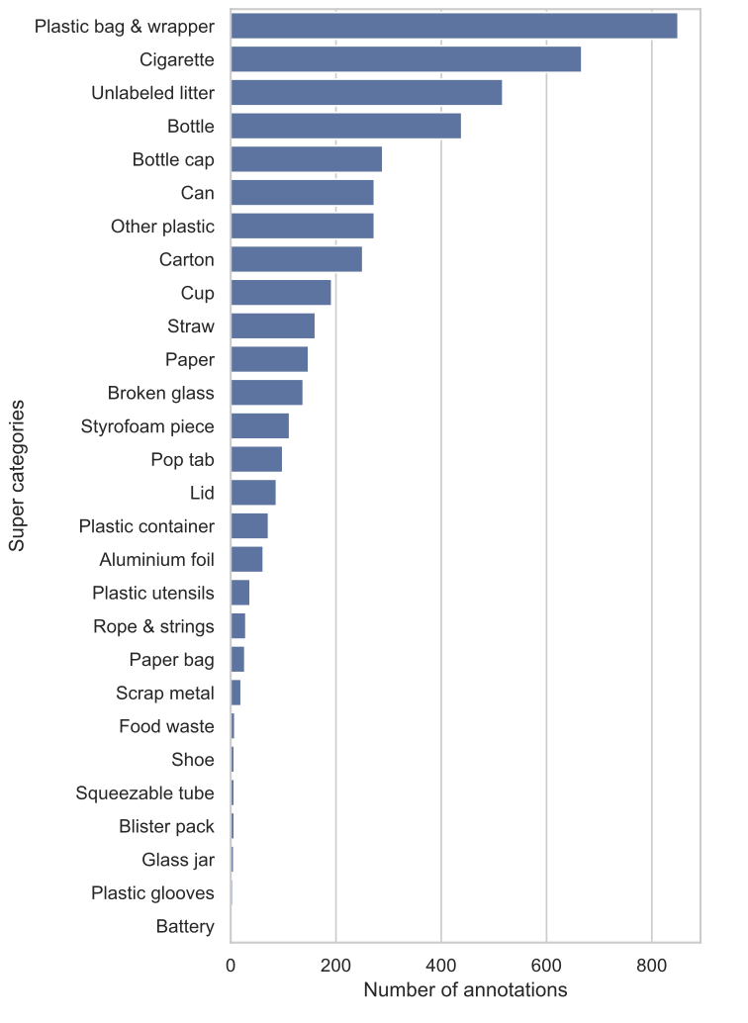

Figure 16: Number of annotations per super category provided by TACO’s current version.

**COCO**: Alongside TACO dataset, we can cooperate TACO with Microsoft COCO dataset. COCO is a large-scale object detection, segmentation, and captioning dataset. It contains 330K images of 1.5 million object instances with 200K images labeled and classified into 80 object categories [12]. **We are going to use only the related objects from the dataset which are trash and waste objects** since the dataset is full of other objects that are not relevant to us in the meantime.

Finally, we intend to learn YOLO Using these two datasets combined together in detecting trash objects to reduce biased results.

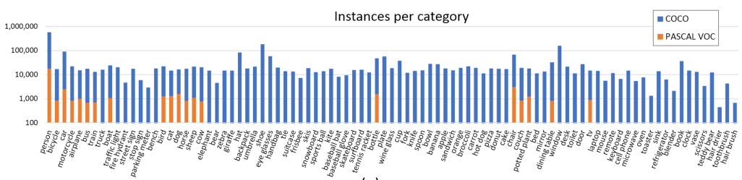

Figure 17: Istances per category for COCO & PASCAL VLOC

#### 4.1.4.2 datasets for grabbing trash by hand detection.

We are going to train MediaPipe using a dataset that contains a set of 4450 landmark coordinates of opened and closed hand.

Each hand has 21 key points as shown in the following Figure.

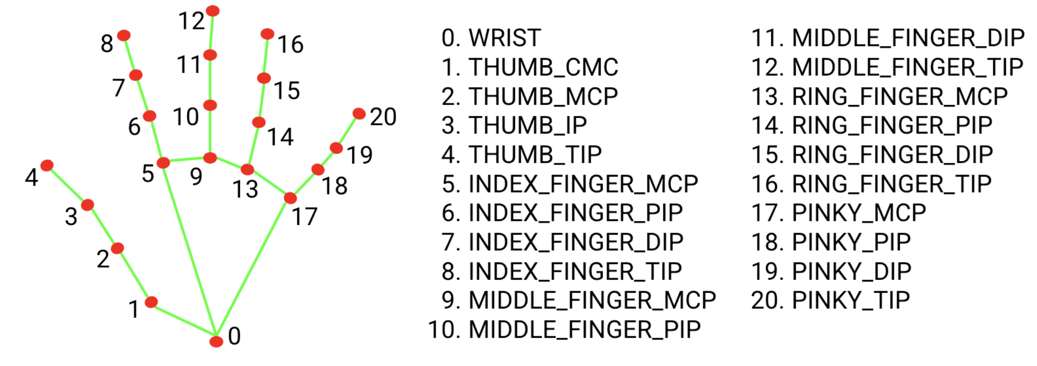

Figure 18: 20 key points In the hand and their names.

For each landmark of the 4450 landmarks, we represent the 20 key points of it in a table like the following Figure when each column represents one of the key points. The first column for the key point number 0, the second column for the key point number 1 etc.

We represent each key point with two coordinates [x, y] which helps us to know the position of the key in the picture. With these coordinates the MediaPipe can determine whether the hand is closed or opened.



Figure 19: A table representing the position of each key point in the hand

To use these coordinates and to use them in the machine learning model of MediaPipe they must first undergo with the following stages of preprocessing [see figure 19]:

1. Converting each coordinate to a relative coordinate to (ID:0)

2. Flatten each coordinate to a one-dimensional array

3. Normalizing the coordinates

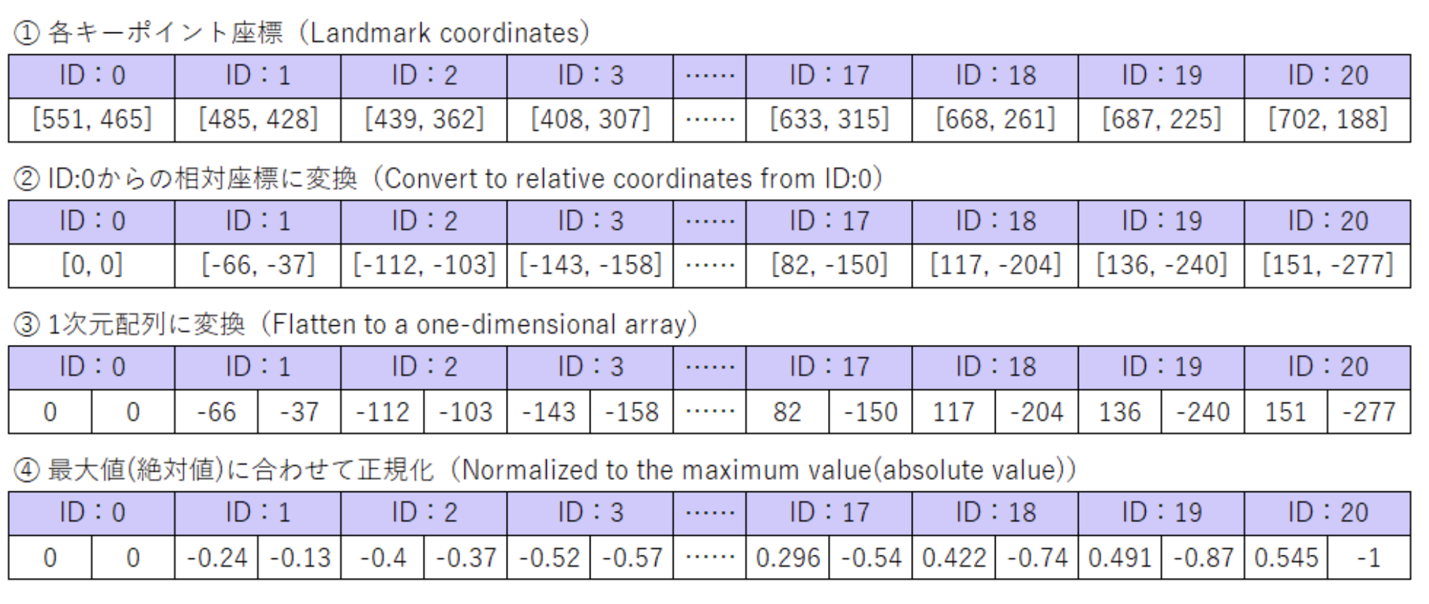

Figure 20: The stages of preprocessing that each landmark must unergo

After each one of the 4450 landmarks undergoes with the stages of preprocessing from 1- 4, we get this dataset to train MediaPipe on:

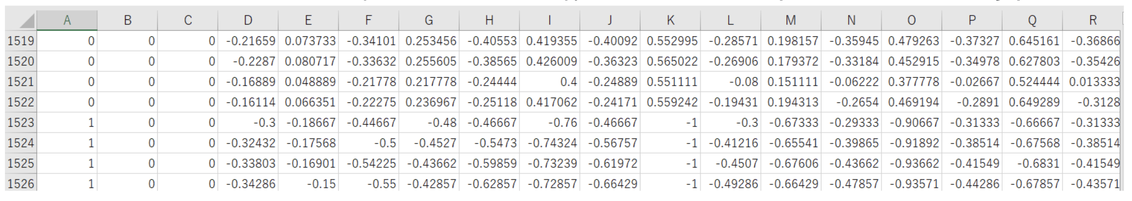

Figure 21: The final 4450 landmarks

### **4.1.5 Development method**

Based on the structure of the final project, we've determined that the Waterfall approach aligns best with our needs. Upon completing phase 'A' of the project, we've established the system's requirements, design, and testing plan. Moving forward, we'll focus on implementation and verification in the subsequent phases. This sequential approach ensures thorough completion of each component before progressing to the next, fostering clarity and confidence in our project progression.

### **4.1.6 Challenges**

The challenges that we may have:

1. **Dataset**: we will have to create a large data set of a hand holding an object since the pose of the hand depends on the object that is being hold.
2. **Distinguish between unintentional gestures**: since the model can get it wrong then we want the user to hold the object near the camera for 1 second.
3. **Hardware**, to train the model we need a powerful CPU, we can use the computer in the collage for the training.
4. **Real-time Performance**: Achieving real-time performance for inference on resource-constrained devices, such as mobile phones or embedded systems, can be challenging due to the computational complexity of hand pose estimation and object recognition algorithms. To handle that we will employ several strategies. We will optimize models through techniques like quantization, pruning, and knowledge distillation to reduce model size and computational demands. We will use efficient architectures such as Mobile Net or custom-designed lightweight models to maintain performance without heavy resource usage.
5. **Dealing with a moving camera**, which may result in unclear feed. To mitigate this, it`s enough to train the model on a large data set.

## **4.2 product**

### **4.2.1 Software Architecture Diagram**

This diagram represents the components of the software system of our app, and represents the functions, their implementations, and their interrelationships. It involves mainly the client app (Frontend)  component, the server (Backend) component, and the database component.

**Client App**:

* The client app is built using React, which is a popular JavaScript library for building user interfaces.
* It utilizes HTML and CSS for rendering the web pages and styling, respectively.

**Server**:

* The server component consists of several sub-components:
  + **Node.js:** A JavaScript runtime environment for executing server-side code.
  + Prediction: This component likely handles making predictions or inferences based on incoming data.
  + **ML Model:** This component represents a machine learning model, which is responsible for tasks such as detecting trash items, hand movement.
  + **YOLO**: an object detection algorithm for detecting and recognizing the trash items.
  + **MediaPipe:** a framework for detecting and processing the movement of the hand.

**Database**:

* The app uses MongoDB, a NoSQL database, for storing data.
* The "Users DB" component represents a collection or database for storing user-related information.

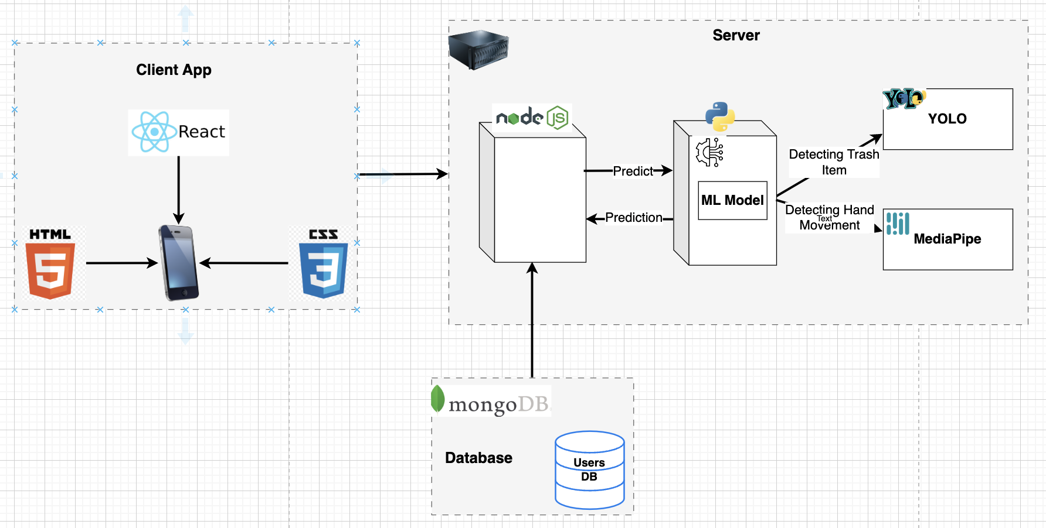

Figure 22: Software Architecture Diagram

### **4.2.2 UseCase Diagram**

The diagram represents a Use Case diagram, which is a visual representation of the functionalities or use cases of a system from a user's perspective. It depicts the interactions between the system and its actors.

The use cases are as follows:

1. **Start new session:** initiate a new session in the app for the user.
2. **Login:** user authenticate and log in to the system.
3. **SignUp:** create an account and register with the system.
4. **View score table**: view a table or scoreboard, which displays scores or rankings of other users. The user can also **“view other’s profile”**.
5. "**View profile**": view the personal profile within the system. The user can also **“edit profile”** in order to modify his own profile’s information.

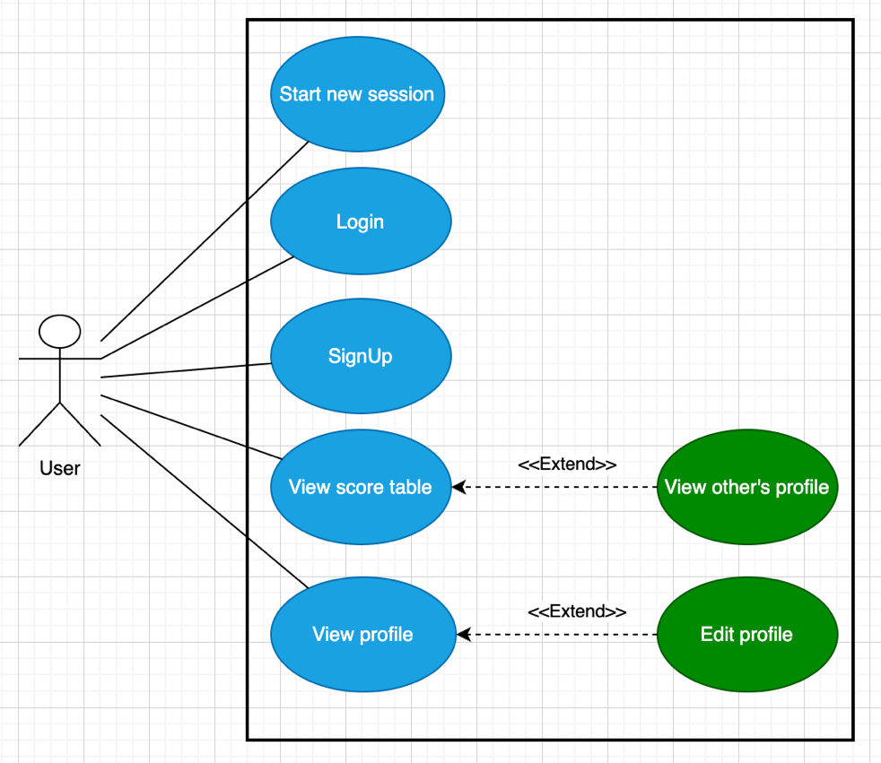

Figure 23: use case diagram

### **4.2.3 Activity Diagram**

This activity diagram illustrates the primary actions users take within the system and outlines how the system responds to these actions.

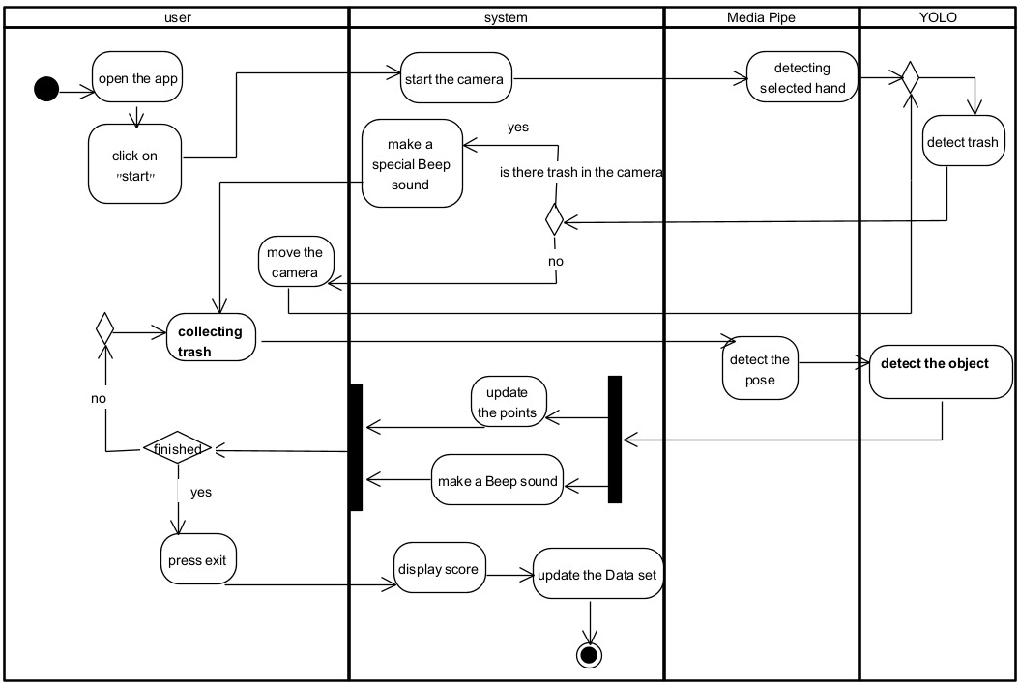

Figure 24: Activity Diagram

The user opens a session for collecting trash, the camera starts and Media-pipe starts working in the background. Media-pipe follows the preferred hand of the user (the hand that the user will use to pick up the trash), and it recognizes when the user picks up the trash, If the camera is directed on the trash the user will hear a special beep (indicating that he can start collecting the trash). The program makes a beep sound (indicating that an object was lifted).

The program uses YOLO to identify the object that was picked and the program gives the user the points according to the kind of trash that was collected (paper- 5 points, plastic- 10 points, organic- 3 points, glass – 6 points, batteries- 8 points, clothes- 3 points, metal- 6 points) . The user can select to finish whenever he wants, and the score will be presented.

### **4.2.4 User-Friendly Interface**

Creating a user-friendly interface for an app is crucial and essential for enhancing User Experience. Therefore, we are planning to build the following interface for our app.

**Home Page**

The home page contains the following buttons and data:

* Current Points - the points he collected and earned in previous sessions.
* Profile Button - displays the profile and the personal information of the player.
* Start Button - to begin a session.
* Player’s high scores button- display the top scores of other players and their collected points.

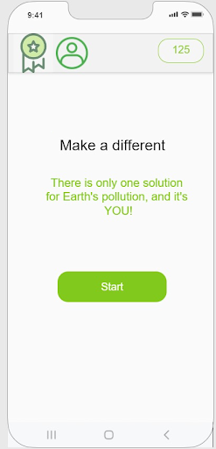

Figure 25: Home page for the app

**Real-Time Waste Detection Page**

Clicking on the Start button in the main page opens the following page that contains:

* Collected and earned points in the current session.
* END button - to end the session and save the earned points.
* An area for capturing the video.
* Object field name - showing the collected trash name.
* An arrow button to back to the home page

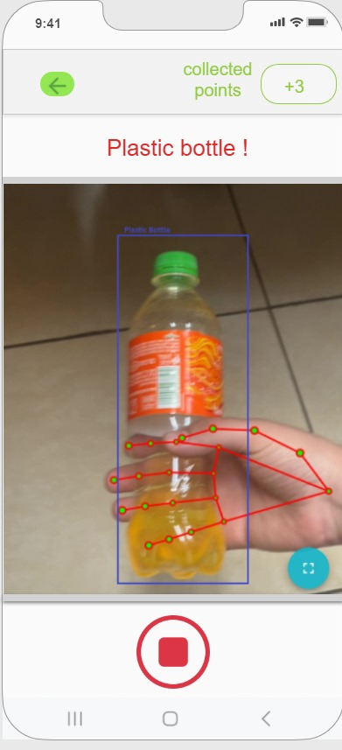

Figure 26: Snapshot of a trash collection session in progress

**Personal Info Page**

Clicking on the Profile button in the top-left corner of the page in the main page opens the following page that contains:

* Player’s personal information such as his first and last names, location, and the year he joined the app, and his current points.
* The total number of points he collected since he joined the app.
* Best score that he collected in one and the same session.
* Hand preference (which means in which hand he prefers to collect the trash). In case he wants to change his hand preference he can do it by clicking on the hand icon or button.
* Tell your friends button - the player can share the app to others using other social media apps.
* Settings button - for Logout from the app or change other personal information.
* An arrow button to back to the home page

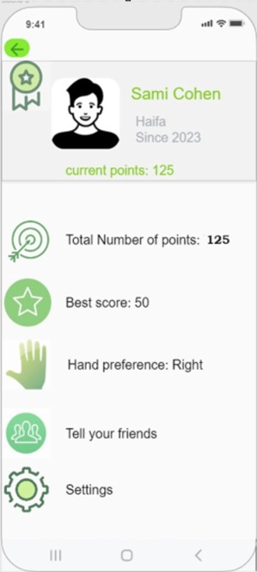

Figure 27: Personal Info Page

**Best Scores Page**

Clicking on the high scores button in the top-left corner of the page in the main page opens the following page that contains:

* This page displays a table of the top scores or the high scores of other players.
* The rank of each player including the player himself that opens this page.
* The current collected points of the player that opens this page.
* An arrow button to back to the home page

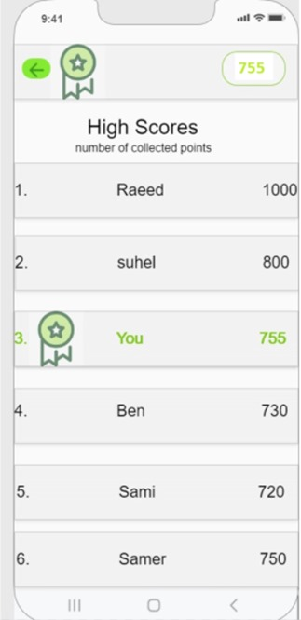

Figure 28: Best Scores Page

# **5. Verification Plan:**

## 5.1 Tests

#### **1. Test the accuracy of trash item recognition**

* Expected Result: The system The system succeeds with 90% accuracy.
* Measurement: Evaluate the percentage of correctly identified objects.
* Explanation: By evaluating recognition accuracy, the system's effectiveness in classifying trash items is determined, aiding in proper waste management.

#### **2. Test hand detection with different skin tones and hand sizes**

* Expected Result: The system is not biased twoards specific hand’s data in 85% of the times
* Measurement: Evaluate the percentage of correctly detected hand movements among participants with varying skin tones and hand sizes.
* Explanation: This test ensures inclusivity and reliability by verifying that the system can detect hands of different appearances and dimensions effectively.

#### **3. Test the precision of trash item recognition on images cropped by the hand tracking model**

* Expected Result: The system maintains high precision in recognizing trash items even when using cropped images with 85% accuracy.
* Measurement: Compare the precision of trash item recognition between full-frame and cropped images.
* Explanation: Assessing precision on cropped images validates the efficacy of hand tracking in providing relevant image segments, ensuring accurate trash item recognition without unnecessary background noise.

#### **4. Test the Beep Sound Notification on Object Detection Expected Result**

* Expected Result: The system emits a beep sound when an object is successfully detected.
* Measurement: Observe and record the occurrence of the beep sound upon object detection and compare it against the number of successful detections.
* Explanation: This test verifies that the auditory notification feature is functioning correctly. The beep sound serves as immediate feedback to users, confirming that the system has recognized an object, thus enhancing user experience and engagement. The reliability of this feature is crucial for maintaining user awareness and interaction during the trash collection process.

#### **5. Test hand detection accuracy from different camera angles**

* Expected Result: The system accurately detects hands across various angles and distances with 80% accuracy.
* Measurement: Evaluate the percentage of correctly detected hand movements at different camera angles and distances.
* Explanation: This test ensures that the hand detection algorithm performs reliably under different spatial conditions, crucial for user interaction with the app.

#### **6. Test hand detection performance on various background types**

* Expected Result: The system effectively distinguishes hand movements from different background types in 80% of the cases.
* Measurement: Assess the ratio of correctly detected hand movements against background noise and clutter.
* Explanation: By testing against different backgrounds, the system's robustness in real-world environments is evaluated, ensuring accurate hand detection irrespective of background complexity.

#### **7. Test the accuracy of the counting mechanism in counting the number of trash items collected**

* Expected Result: The system accurately counts the earned points.
* Measurement: Compare the counted number of items with the expected number to assess counting accuracy.
* Explanation: Accurate counting ensures efficient waste management, and this test verifies the reliability of the system in quantifying collected trash items.

#### **8. Test the storing of the earned points in the DB (database of the users)**

* Expected Result: The system successfully saves the new points in DB.
* Measurement: Verify the database entries for the user's points after collecting trash items to ensure they match the earned points.
* Explanation: This test ensures the integrity and reliability of the database operations. Accurate storage of earned points is crucial for maintaining user engagement and rewarding their efforts correctly.

#### **9. Test saving the data in of the user when signing up in DB**

* Expected Result: The system successfully saves the new user data in the database upon signing up.
* Measurement: Verify the database entries for new users by comparing the input data during the sign-up process with the records stored in the database.
* Explanation: This test ensures the reliability and accuracy of the user registration process. Correctly saving user data during sign-up is essential for user account creation, enabling personalized experiences, and ensuring that users can subsequently access their accounts without issues.

#### **10. Test the login process**

* Expected Result: The system successfully logs in the user and grants access to their profile.
* Measurement: Track the login success rate by comparing the number of successful logins to the total login attempts, aiming for a 95% success rate.
* Explanation: Ensuring a smooth and reliable login process is essential for user satisfaction. This test verifies that users can securely access their accounts without unnecessary hindrances.

#### **11. Test editing the personal profile of the user**

* Expected Result: The system successfully saves the updated personal profile information in the database.
* Measurement: Check the database to confirm that changes made by the user to their profile are correctly reflected and saved.
* Explanation: This test confirms the app's ability to handle and save user data accurately. It is vital for providing a personalized experience and maintaining user trust in the app's functionality.

#### **12. Test viewing the scores of other users**

* Expected Result: The system successfully retrieves and displays the scores of other users.
* Measurement: Validate the accuracy of displayed scores by cross-referencing them with the database records.
* Explanation: This test ensures that the leaderboard and social features work correctly, fostering a competitive and engaging environment for users by accurately reflecting their and others' contributions.

#### **13. Test the full process of collecting the trash and getting the points**

* Expected Result: The system correctly tracks the collection process, recognizes trash items, updates the points, and stores them in the database.
* Measurement: Monitor the entire workflow from trash detection to point allocation and storage, ensuring all intermediate steps function seamlessly.
* Explanation: This comprehensive test verifies the app's core functionality, ensuring that all integrated components (detection, tracking, counting, and database update) work together smoothly to provide a consistent user experience.

#### **14. Test application performance in terms of speed and responsiveness under varying loads**

* Expected Result: The application maintains speed and responsiveness under different user loads.
* Measurement: Measure response time and latency under varying concurrent user loads.
* Explanation: Ensuring consistent performance under different loads guarantees a seamless user experience, crucial for the app's usability during peak usage times.

## 5.2 Constraints

1. **Hardware Limitations:** The performance of the app may be constrained and limited by the capabilities of the mobile devices used by participants. We know that for example older devices may have limited processing power and memory, affecting the speed and accuracy of hand detection and trash recognition.

2. **Environmental Factors:** Real-world environments can come with unpredictable factors such as varying lighting conditions, background clutter. These environmental factors can impact the performance of hand detection and trash recognition.

3. **Data Diversity:** Since our system uses machine learning algorithms in its core, the system may suffer from limited or biased training data may lead to suboptimal performance, especially when dealing with diverse hand shapes, skin tones, and trash items. Therefore, we intend as much as we can to utilize and build a diverse training data.

## 5.3 Assumptions

1. **Consistent User Interaction:** The testing process assumes that users will interact with the application in a predictable and consistent manner. This means that users will follow the expected behaviors and interaction patterns as designed within the app, such as correctly positioning the camera for trash detection and using the hand gestures as intended.

2. **Optimal Environmental Conditions:** The testing assumes that the application will be used in environments with adequate lighting. Low-light conditions can adversely affect the performance of computer vision and hand tracking capabilities; thus, this presumption ensures that the app is tested under conditions where it can perform optimally.

3. **Stable Network Connectivity:** The testing presumes that there is stable network connectivity available during the use of the application. Reliable network access is necessary for functionalities such as real-time data synchronization, user authentication, and database interactions.

## 5.4 Other important considerations: user’s evaluation, and feedback

### **5.4.1 User Interface Evaluation**

* Gather feedback from 10 people (from different ages) on the clarity and intuitiveness of the app's interface for users engaged in trash collection activities.
* Identify any areas for improvement or features that could enhance user experience.
* Some of the questions that they will get: How would you rate the app's interface in terms of clarity and intuitiveness? Was the app easy to navigate and understand on your first use? Were there any points where you felt lost or unsure of what to do next? What specific features or areas do you think could be improved to enhance your experience?

### **5.4.2 Asking for General Feedback**

* Gather overall impressions from 10 people (from different ages) of the usefulness and effectiveness of the trash collection system.
* Collect recommendations and suggestions for improvements from users, particularly regarding features that could enhance their trash collection experience.
* Some of the questions that they will get: Can you share your overall impressions of the usefulness and effectiveness of the trash collection system? How well do you think the system helps in managing and collecting trash efficiently? What recommendations or suggestions do you have for improving the system? Are there any specific features you believe could enhance your trash collection experience?

# **6.** **References**

1. Adam Ran,Gal Lahat.(2021) Clean coin. <https://www.clean-coin.com/>

2. Arijit Mallick (2017). Deep Learning for Object Recognition in picking tasks. ROBINLAB, University of Jaume <https://www.researchgate.net/publication/322925772_Deep_Learning_for_Object_Recognition_in_picking_tasks>

3. Camillo Lugaresi, Jiuqiang Tang, Hadon Nash, Chris McClanahan, Esha Uboweja, Michael Hays, Fan Zhang, Chuo-Ling Chang, Ming Guang Yong, Juhyun Lee, Wan-Teh Chang, Wei Hua, Manfred Georg and Matthias Grundmann (2019). MediaPipe: A Framework for Building Perception Pipelines. Google Research.   
[[1906.08172] MediaPipe: A Framework for Building Perception Pipelines (arxiv.org)](https://arxiv.org/abs/1906.08172)

4. Chien-Yao Wang1,2, I-Hau Yeh2 , and Hong-Yuan Mark Liao (2024). YOLOv9: Learning What You Want to Learn Using Programmable Gradient Information. Institute of Information Science, Academia Sinica, Taiwan National Taipei University of Technology, Taiwan Department of Information and Computer Engineering, Chung Yuan Christian University, Taiwan. <https://arxiv.org/pdf/2402.13616>

5. Dr.Kundu, R. (2023). YOLO: Algorithm for Object Detection.

https://www.v7labs.com/blog/yolo-object-detection

6. Guillermo Sánchez‑Brizuela, Ana Cisnal, Eusebio de la Fuente‑López, Juan‑Carlos Fraile, Javier Pérez‑Turiel (2023). Lightweight real‑time hand segmentation leveraging MediaPipe landmark detection. Springer Link  
[Lightweight real-time hand segmentation leveraging MediaPipe landmark detection | Virtual Reality (springer.com)](https://link.springer.com/article/10.1007/s10055-023-00858-0)

7. Huang, Z., Huang, L., Gong, Y., Huang, C., & Wang, X.(2019) Mask Scoring R-CNN. Institute of AI, School of EIC, Huazhong University of Science and Technology & Horizon Robotics Inc.  
[Huang_Mask_Scori ng_R-CNN_CVPR_2019_paper.pdf (thecvf.com)](https://openaccess.thecvf.com/content_CVPR_2019/papers/Huang_Mask_Scoring_R-CNN_CVPR_2019_paper.pdf)

8. Jeff Kirschner,Dick Ayres,Sean Doherty (2017).litterati. <https://www.litterati.org/>

9. Jinqiang Bai, Shiguo Lian, Member, IEEE, Zhaoxiang Liu, Kai Wang, Dijun Liu (2018). Deep Learning Based Robot for Automatically Picking up Garbage on the Grass.  
[Deep Learning Based Robot for Automatically Picking Up Garbage on the Grass | IEEE Journals & Magazine | IEEE Xplore](https://ieeexplore.ieee.org/abstract/document/8419288)

10. Laith Alzubaidi, Jinglan Zhang, Amjad J. Humaidi, Ayad Al‑Dujaili, Ye Duan, Omran Al‑Shamma, J. Santamaría, Mohammed A. Fadhel, Muthana Al‑Amidie, Laith Farhan (2021). Review of deep learning: concepts, CNN architectures, challenges, applications, future directions. Journal of Big Data.   
[Review of deep learning: concepts, CNN architectures, challenges, applications, future directions | Journal of Big Data | Full Text (springeropen.com)](https://journalofbigdata.springeropen.com/articles/10.1186/s40537-021-00444-8)

11. Proença, P. F., & Simões, P.. (2020)TACO: Trash Annotations in Context for Litter Detection.<https://www.researchgate.net/publication/339972443_TACO_Trash_Annotations_in_Context_for_Litter_Detection>

12. Tsung-Yi Lin, Michael Maire, Serge Belongie, Lubomir Bourdev, Ross Girshick, James Hays, Pietro Perona, Deva Ramanan, C. Lawrence Zitnick, Piotr Dollar (2015). Microsoft COCO: Common Objects in Context.   
[[1405.0312] Microsoft COCO: Common Objects in Context (arxiv.org)](https://arxiv.org/abs/1405.0312)